Covedale Center for the Performing Arts
2023 – 2024 Marquee Subscription Season
at the
Arnold and Mary Jo Barnett Performance Hall

ON SALE NOW!!!!

Come enjoy great theatrical entertainment – at a great price! The subscriber rate is only $28.00 per ticket ($140.00 for 5 show package). The Covedale has plenty of great subscriber seats available with a great view of the stage! New subscribers are encouraged to get their seats now, for best seating choices. Be sure to check out the seating chart at www.CLPShows.org

BRIGHT STAR September 7 – October 1, 2023
Music, Book & Story: Steve Martin Music, Lyrics & Story: Edie Brickell
Featuring the Tony®-nominated score by Steve Martin and Edie Brickell, Broadway’s BRIGHT STAR tells a true tale of love and redemption set against the rich backdrop of the American South in the 1920s and ’40s. When literary editor Alice Murphy meets a soldier just home from World War II, he awakens her longing for the child she once lost. Haunted by their unique connection, they set out to understand her past—and find the power to transform both their lives. With beautiful melodies and powerful characters, BRIGHT STAR is refreshingly genuine and daringly hopeful.
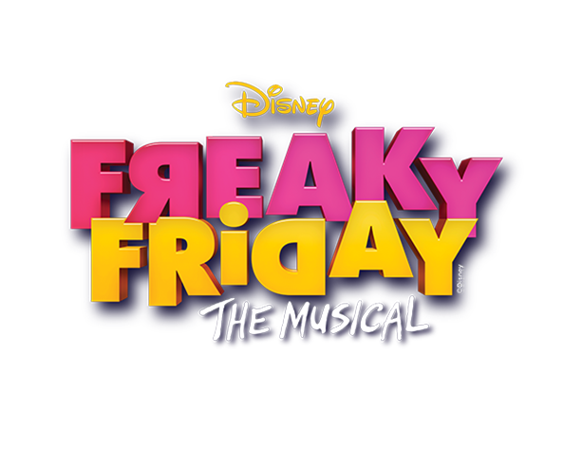

FREAKY FRIDAY October 12 – November 5, 2023
Book By Bridget Carpenter Music By Tom Kitt Lyrics By Brian Yorkey
Based on the Novel Freaky Friday by Mary Rodgers and the Disney films.
When an overworked mother and her teenage daughter magically swap bodies, they have just one day to put things right! FREAKY FRIDAY is a heartfelt, comedic, and unexpectedly emotional update on a hilarious, modern American classic. By spending a day in each other's shoes, Katherine and Ellie come to appreciate one another's struggles, and realize the immeasurable love that bonds a mother and daughter. With great songs like, “One More Day”, “Parents Lie!” and “No More Fear”, FREAKY FRIDAY will make you laugh till you cry and maybe, cry till you laugh!

WHITE CHRISTMAS Nov. 30 – Dec. 23, 2023
Music and Lyrics by Irving Berlin Book by David Ives and Paul Blake
Based upon the Paramount Pictures Film written for the Screen by Norman Krasna, Norman Panama and Melvin Frank.
Veterans Bob Wallace and Phil Davis have a successful song-and-dance act after World War II. With romance in mind, the two follow a duo of beautiful singing sisters en route to their Christmas show at a Vermont lodge, which just happens to be owned by Bob and Phil's former army commander. With a dazzling score featuring well-known standards including “Blue Skies,” “The Best Things Happen When Your Dancing,” “Count Your Blessings,” “Snow and the perennial classic, White Christmas!
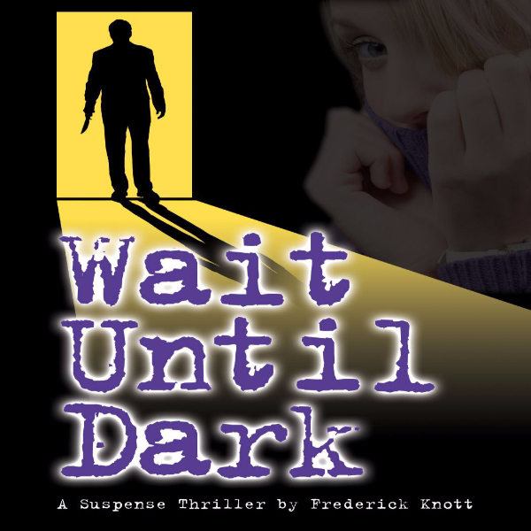
WAIT UNTIL DARK January 25 – February 18, 2024
By Frederick Knott. Adapted by Jeffery Hatcher
Forty-seven years after Wait Until Dark premiered on Broadway, Jeffrey Hatcher has adapted Frederick Knott's 1966 original, giving it even more menace and suspense! In 1944 Greenwich Village, Susan Hendrix, a blind yet capable woman, is imperiled by a trio of men in her own apartment. As the climax builds, Susan discovers that her blindness just might be the key to her escape, but she and her tormentors must wait until dark to play out this classic thriller's chilling conclusion. Considered one of the scariest moments ever staged, the final minutes of WAIT UNTIL DARK will keep your heart pounding to the very last second!

SEE NEXT PAGE FOR THE FINAL BIG SHOW OF THE 2023-2024 SEASON…

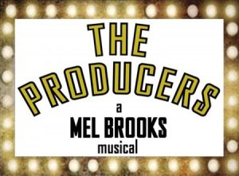
THE PRODUCERS! March 14 – April 7, 2024
Book by Mel Brooks and Thomas Meehan. Music and Lyrics by Mel Brooks.
Mel Brooks' classic-cult-comedy-Broadway-musical comes to the Covedale! Our 2015 production sold out in hours, leaving many laugh-hungry patrons unable to see the show!
Now it’s back! Come giggle and cheer as a down-on-his-luck Broadway producer and his mild-mannered accountant try to produce the biggest flop in history, bilking their backers out of millions of dollars! Only one thing goes awry: the show is a smash hit! With a slew of gloriously outrageous songs like “Springtime For Hitler”, “Prisoners of Love” and “I Wanna Be a Producer”, the show skewers Broadway while setting the standard for in-your-face-humor. At the core of this insanely funny adventure is a poignant emotional journey of two very different men who become friends, making for a truly boffo show, that won a record twelve Tony Awards. It’s sure to wow capacity crowds night after night!

IMPORTANT DATES:
Subscriptions on sale Saturday, January 21, 2023
Subscription renewal deadline is Friday, July 21, 2023
Subscription package tickets will be mailed Friday, August 4, 2023
Single tickets go on sale, Monday, August 7, 2023
Single ticket pricing: $33.00 for Adults; $30 for Students and Seniors

Due to availability, season titles are subject to change.
Please note performance times: Thursday 7:30 pm; Friday 8:00 pm; Saturday 8:00pm; & Sunday 2:00pm.

Complete Performance Date Listing:

Bright Star Freaky Friday
Thurs. Sept. 7 - Fri. Sept. 8 – Sat. Sept. 9 – Sun. Sept. 10 Thurs. Oct. 12 - Fri. Oct. 13 – Sat. Oct. 14 – Sun. Oct. 15
Thurs. Sept. 14 – Fri. Sept. 15 – Sat. Sept. 16 – Sun. Sept. 17 Thurs. Oct. 19 - Fri. Oct. 20 – Sat. Oct. 21 – Sun. Oct. 22
Thurs. Sept. 21 – Fri. Sept. 22 – Sat. Sept. 23 – Sun. Sept. 24 Thurs. Oct. 26 – Fri. Oct. 27 – Sat. Oct. 28 – Sun. Oct. 29
Thurs. Sept. 28 – Fri. Sept. 29 – Sat. Sept. 30 – Sun. Oct. 1 Thurs. Nov. 2 – Fri. Nov. 3 – Sat. Nov. 4 – Sun. Nov. 5

White Christmas Wait Until Dark
Thurs. Nov. 30 – Fri. Dec. 1 – Sat. Dec. 2 – Sun. Dec. 3 Thurs. Jan. 25 – Fri. Jan. 26 – Sat. Jan. 27 – Sun. Jan. 28
Thurs. Dec. 7 – Fri. Dec. 8 – Sat. Dec. 9 – Sun. Dec. 10 Thurs. Feb. 1 – Fri. Feb. 2 – Sat. Feb. 3 – Sun. Feb. 4
Thurs. Dec. 14 – Fri. Dec. 15 – Sat. Dec. 16 – Sun. Dec. 17 Thurs. Feb. 8 – Fri. Feb. 9 – Sat. Feb. 10 – Sun. Feb. 11
*Wed. Dec. 20 – Thurs. Dec. 21 – Fri. Dec. 22 – Sat. Dec. 23 Thurs. Feb. 15 – Fri. Feb. 16 – Sat. Feb. 17 – Sun. Feb. 18

*Sunday #4 Subscribers moved to Wed. 12/20 due to Christmas Eve

The Producers
Thurs. Mar. 14 – Fri. Mar. 15– Sat. Mar. 16 – Sun. Mar. 17
Thurs. Mar. 21 – Fri. Mar. 22– Sat. Mar. 23 – Sun. Mar. 24
Thurs. Mar. 28 – Fri. Mar. 29– Sat – Mar. 30
*Wed. Apr. 3 - Thurs. Apr. 4 – Fri. Apr. 5 – Sat. Apr. 6 – Sun. Apr. 7

*Sunday #3 Subscribers moved to Wed. 4/3 due to Easter

You can purchase OR renew a subscription by one of the following methods:
- Call the box office @ 513.241.6550
- Mail your subscription order form to: CLP, P.O. Box 5255 Cincinnati, OH 45205
- Log on to: www.CLPShows.org
- In person at the Covedale box office ticket counter
- Single tickets go on sale Monday, August 7, 2023. $33 for Adults; $30 for Seniors/Students

Plus! Don’t miss our 2023 Summer Classic Season at The Warsaw Federal Incline Theater including:

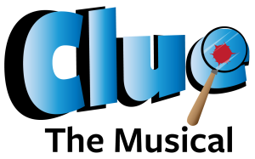
The 2023 Summer Classics Season includes:

CLUE: The Musical April 19 – May 14, 2023
Book by Peter DePietro; Music by Glaen Blum, Wayne Barker and Vinnie Martucci; Lyrics by Tom Chiodo Based on the Parker Brothers’ Board Game
Who killed Mr. Boddy, with what, and where? It might be Mr. Plum with the wrench in the Library, Colonel Mustard with the candlestick in the Dining Room, or Mrs. Peacock with the rope in the kitchen! And it’s the audience who get to play along to the final solution of who done it. Comic antics, witty lyrics, and beguiling tunes carry the investigation from suspect to suspect. Even after the culprit confesses, a surprise twist delights the audience!
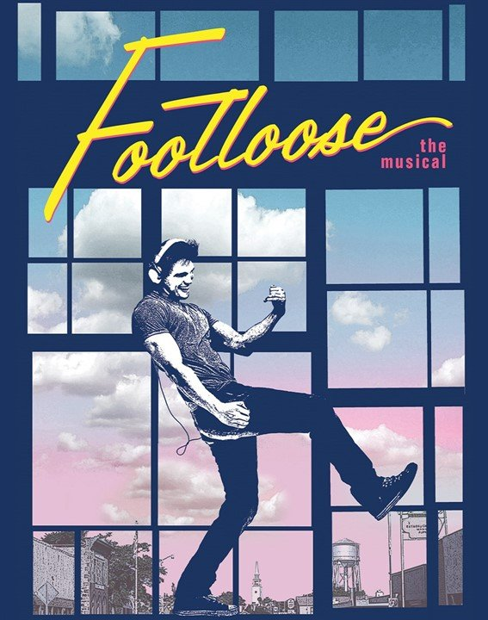
FOOTLOOSE May 31 – June 25, 2023
Music by Tom Snow; Lyrices by Dean Pitchford, Stage Adaptation by Dean Pitchford and Walter Bobbie; Based on the original screenplay by Dean Pitchford; Additional Music by Eric Carmen Sammy Hagar, Kenny Loggins and Jim Steinman
When Ren and his mother move from Chicago to a small Texas town, he is not prepared for the local edict instituted by the local preacher that bans dancing! To the rockin’ rhythm of its Oscar and Tony-nominated score, plus dynamic new songs, Footloose celebrates the wisdom of listening to young people while guiding them with a warm heart and open mind.
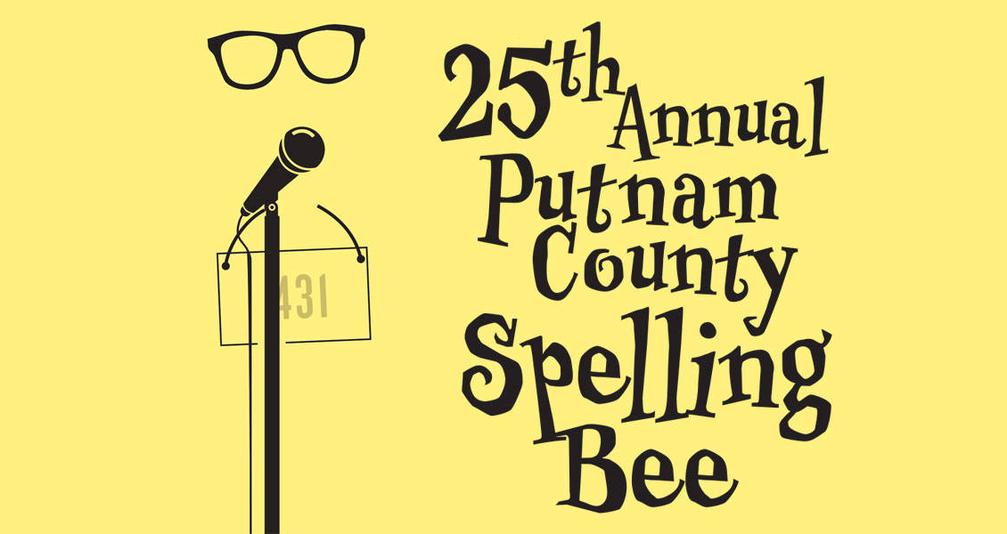
25TH ANNUAL PUTNAM COUNTY SPELLING BEE July 5 – July 30, 2023
Conceived by Rebecca Feldman, Additional Material by Jay Reiss; Music and Lyrics by William Finn; Book by Rachel Sheinkin Jerry Herman, Larry Alford and Wayne Cilento
Additional Materials by Jay Reiss; Originally Directed on Broadway by James Lapine; Originally produced on Broadway by David Stone, James L. Nederlander, Barbara Whitman, Patrick Catullo, Barrington Stage Company, Second Stage Theatre
An eclectic group of pubescent kids vie for the spelling championship of a lifetime. While candidly disclosing hilarious and touching stories from their home lives, the teens spell their way through a series of crazy words, hoping never to hear the soul-crushing, pout-inducing “ding” of the bell that signals a spelling mistake. Six spellers enter; one speller leaves triumphant!

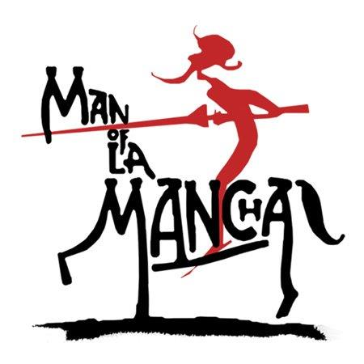
MAN OF LA MANCHA Aug. 16 – Sept. 10, 2023
Written by Dale Wasserman; Music by Mitch Leigh; Lyrics by Joe Darion; Original Production Staged by Albert Marre/Originally Produced by Albert W. Selden and Hal James
One of the world’s most popular musicals! The original 1965 production won five Tony Awards, including Best Musical! Cervantes is in prison awaiting trial when he and his fellow prisoners perform a play-within-a-play, telling of "Don Quixote" who goes on a quest to right all wrongs! The rousing, score includes classics like “The Impossible Dream,” “I, Don Quixote,” “Dulcinea,” and “Little Bird.” Man of La Mancha is an incredible, inspiring show for the ages!
Don’t Miss Cincinnati Young People’s Theatre’s 41st Summer!


Jesus Christ Superstar - July 20 – July 30, 2023
Lyrics by Tim Rice, Music by Andrew Lloyd Webber Cincinnati Young People’s Theatre’s 41st summer!
What’s the buzz? The first musical by Andrew Lloyd Webber and Tim Rice, Jesus Christ Superstar has wowed audiences for 50 years. The rock opera follows the last week of Jesus Christ’s life through the eyes of Judas. Loosely based on the four Gospels, the story is told entirely via some of the most famous songs in theatre history, such as “I Don’t Know How To Love Him”, “Superstar” and “Heaven On Their Minds”.

-For information on all the shows at our great venues, check out – www.clpshows.org

For Office use only D_____ S_____ N_____ U_____

Covedale Center for the Performing Arts
Subscription Order Form for 2023– 2024 Season
(Please fill out completely)

Name: ________________________________ Email:___________________________________

Address/City/State/Zip: ____________________________________________________________

Home Phone #: __________________________ Alternate #: ____________________________

SUBSCRIPTION ORDER INFORMATION:
I would like _____ Marquee series Subscriptions @ $140.00 each for a total of……….. $________
A subscription INCLUDES All Five Season Shows.
The Subscription Package features the low, Subscriber - only price of $28.00 per show.

DONOR SUPPORT ------------ Diamond Level $1,000.00 and above ________
Platinum Level $ 500.00 and above ________
Won’t you consider a tax-deductible donation Gold Level $ 250.00 and above ________
To help keep CLP growing? If you have Silver Level $ 100.00 and above ________
not contributed to our Annual Giving Bronze Level $ 25.00 and above ________
Campaign, you can make a donation now.

TOTAL AMOUNT (Subscriptions + Donor Support) = $ _______________

PAYMENT OPTION INFORMATION:  Enclosed is my check made payable to  Cincinnati Landmark Productions: ________  (Please “X” if check is enclosed) | Payment Address:  Covedale Center for the Performing Arts  P.O. Box 5255  Cincinnati, OH 45205
Credit Card Payment: Name on Card: ____________________________________
Credit Card Number: ____________________________________
Expiration Date: ____________________________________
Billing Zip Code: _________________ CVV:______________

SERIES PERFORMANCE REQUEST: (Choose a performance schedule below - one day and one week for series)
Were you a 2022/2023 Marquee Season Subscriber? YES _____ NO ______

__________ Check here if you wish your day and seats to remain the same.
- Renewing Subscribers are guaranteed their same seats, only if they keep the same day and week AND renew by the deadline.
_______________ Check here if you would like to change your series choice below.
- Seating changes or upgrades are filled on availability and in the order received.

DAY AND TIME WEEK
_____ Thursday 7:30 pm _____ No Preference
_____ Friday 8:00 pm _____ 1st Week of Run
_____ Saturday 8:00 pm _____ 2nd Week of Run
_____ Sunday 2:00 pm _____ 3rd Weed of Run
_____ 4th Week of Run
Please specify wheelchair needs:____________________________________________________

You can purchase OR renew a subscription by one of the following methods:
- Call the box office @ 513.241.6550
- Mail your subscription order form to: CLP P.O. Box 5255 Cincinnati, OH 45205
- Log on @ www.clpshows.org
- In person at the Covedale box office ticket counter

